Chapter 3: Water

3.1 Water can change state

Student worksheet answers (pages 48–49)

The state we’re in

1 Complete the flow chart below to revise your understanding of the states of water.

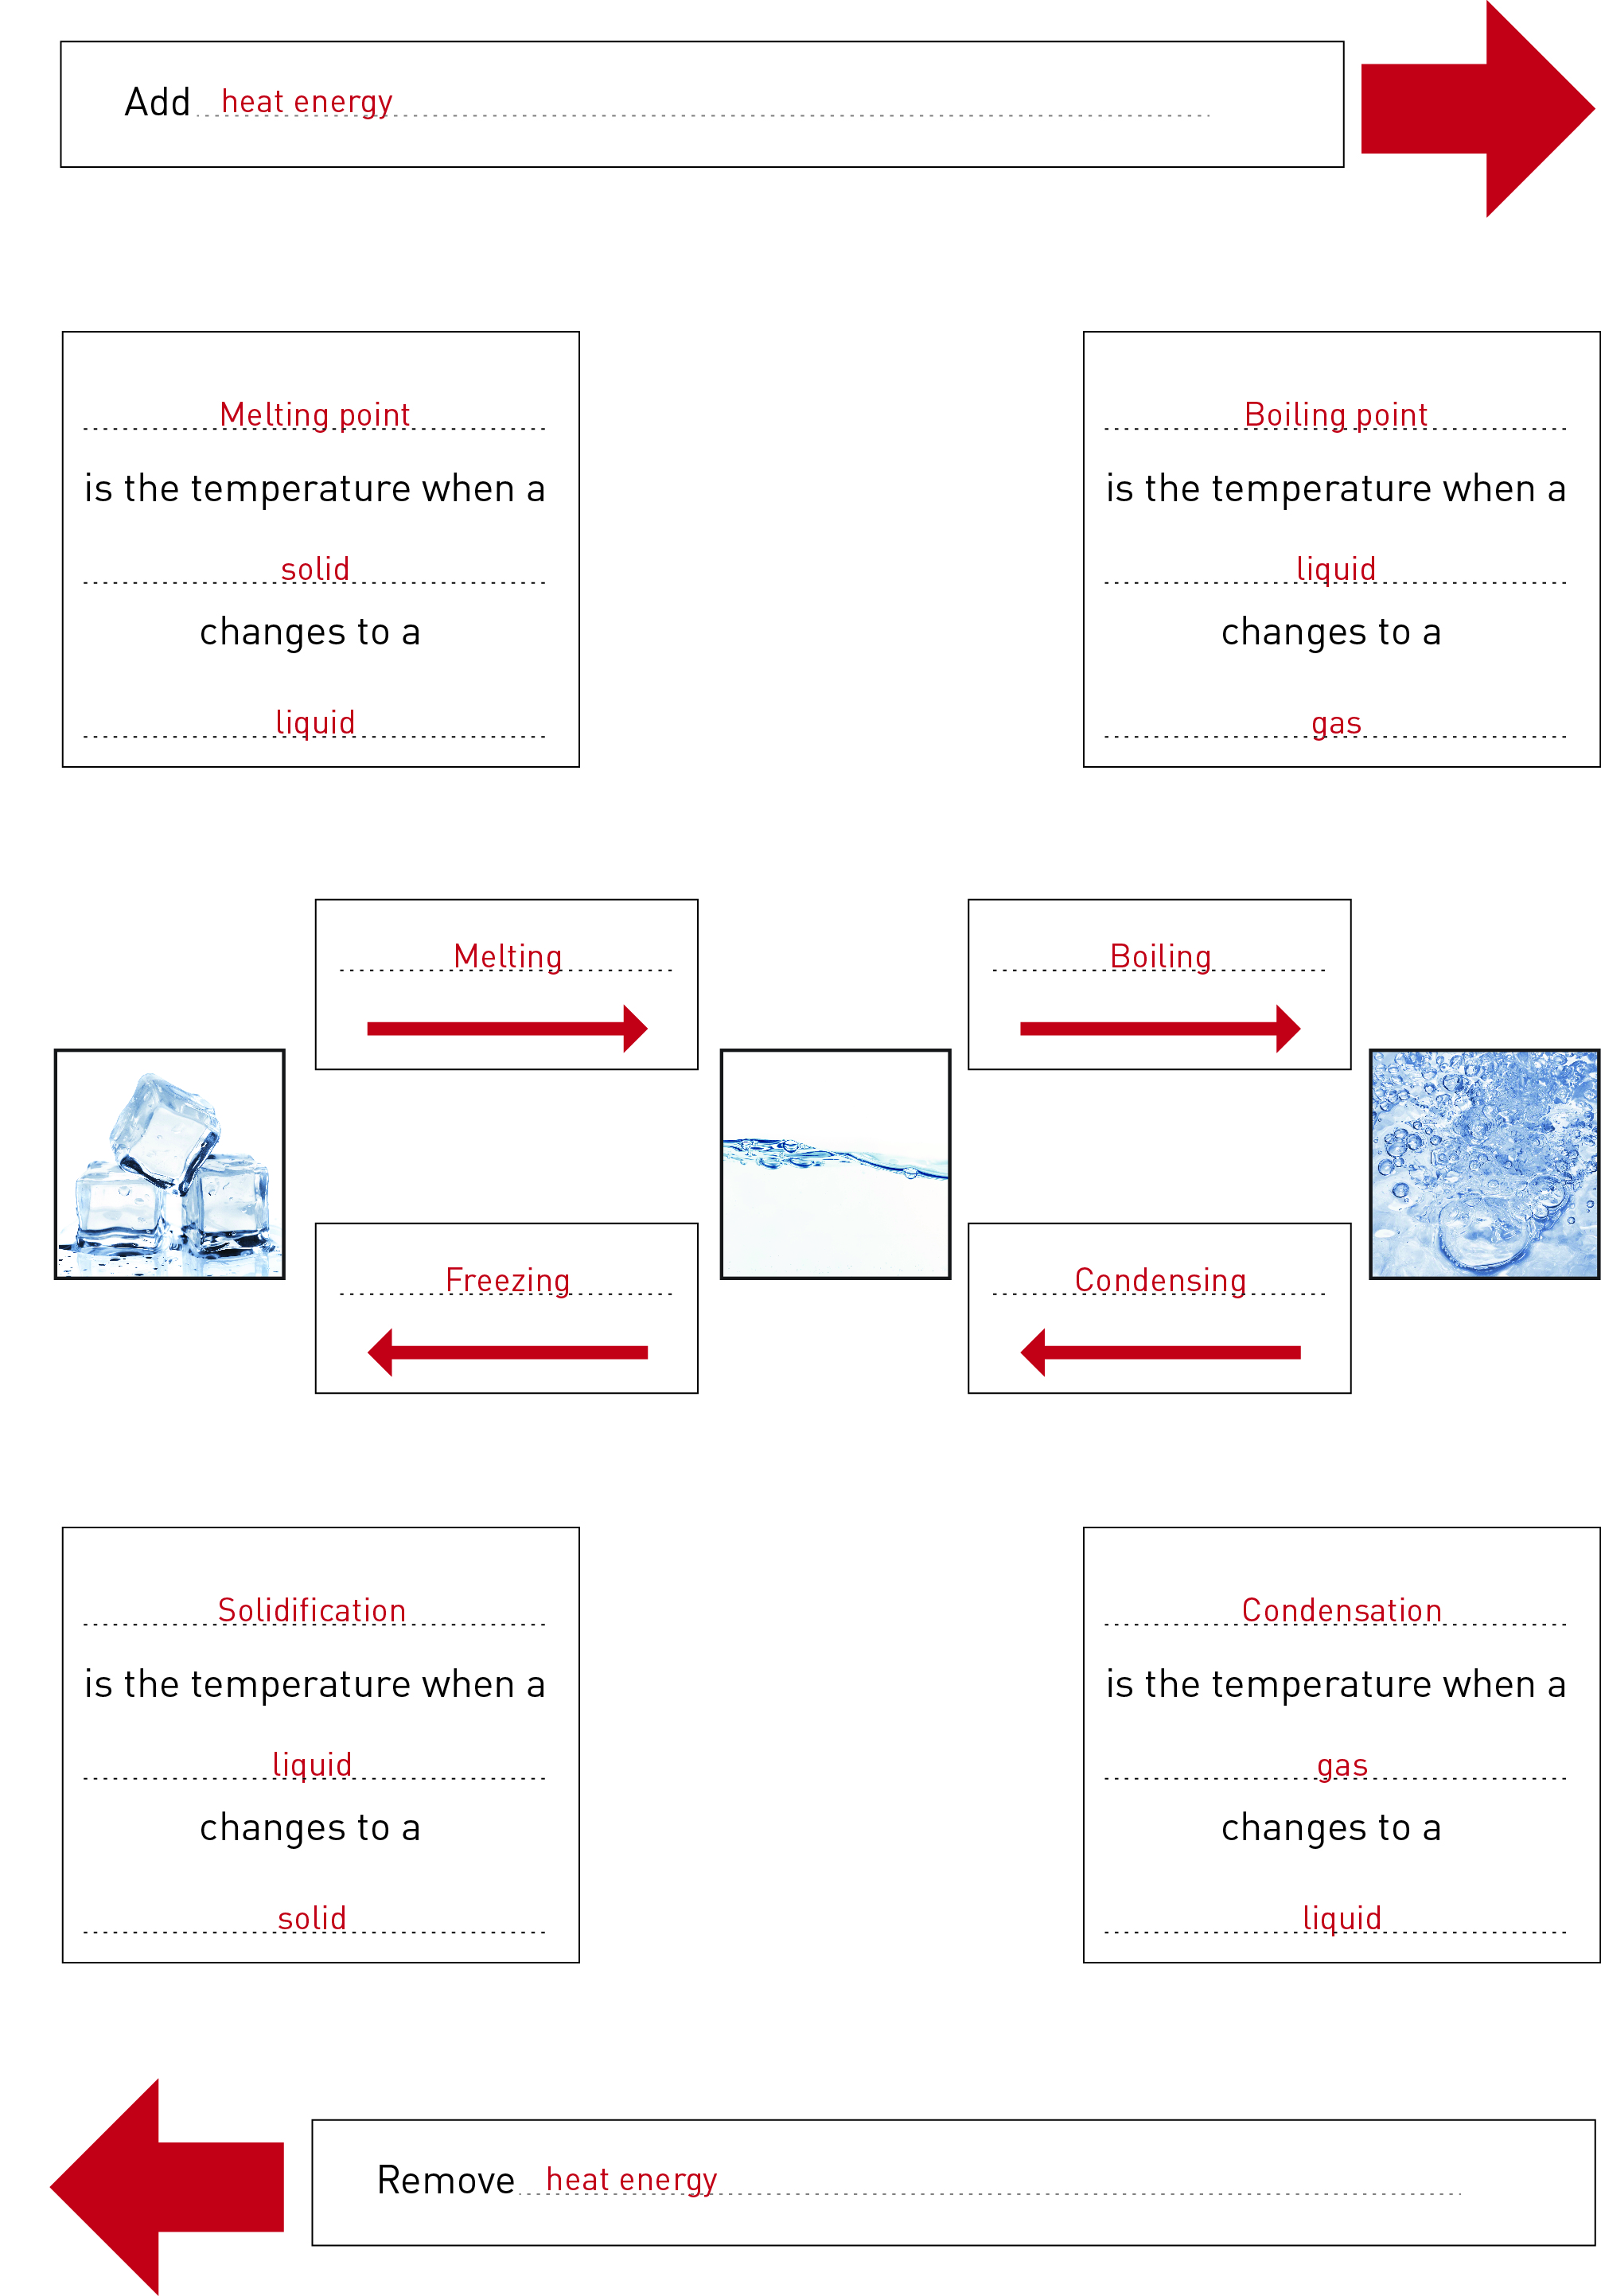

2 After completing the ‘Three States of Water’ experiment, label the diagram below to identify the processes causing the changes of state.

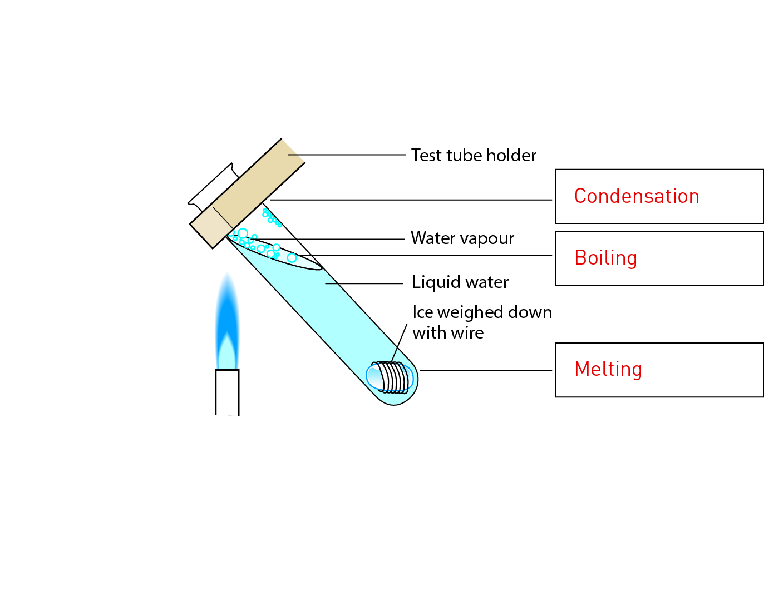

3 Below are a series of change of state equations. Fill in the state in the space provided.

a ice + heat =

water

b water – heat =

ice

c steam – heat =

water

d water + heat =

steam

4 Below are a series of change of state sentences. Fill in the process that leads to the change of state in the space provided.

a When you add heat to ice, the process that causes a change of state is known as:

melting

b When you add heat to water, the process that causes a change of state is known as:

boiling

c When you remove heat from water, the process that causes a change of state is known as:

freezing (solidification)

d When you remove heat from steam the process that causes a change of state is known as:

condensation

EXTEND YOUR UNDERSTANDING

5 A new state of mater called the Bose–Einstein condensate was predicted in the 1920s and proved in the 1990s. Find out what the Bose–Einstein condensate is and whether water can be in this state.

• There are three states of matter that exist naturally on Earth – solid, liquid, and gas. Certain substances, like water, can exist in any of these different states of matter in nature.

• At extremely hot or cold temperatures (that can only be created in laboratories), scientists have been able to create two more states of matter. One, called plasma, can exist at very high temperate (several thousand degrees Celsius). Another, called the Bose–Einstein condensate, forms at very low temperatures near absolute zero (0K or -273.15oC).

• Water cannot exist as a Bose–Einstein condensate.

3.2 Water cycles through the environment

Student worksheet answers (pages 50–51)

Riding with H2O – The water cycle

1 Complete the flow chart below to revise your understanding of the water cycle.

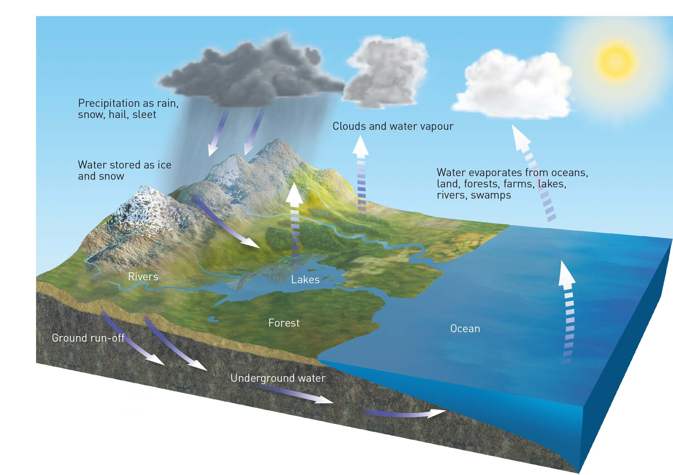

2 What is the role of the Sun in the water cycle?

The Sun provides the heat energy required to melt ice and snow to produce water. The Sun also provides the heat energy required to evaporate water to produce water vapour, which can become clouds.

3 Think about the different processes that lead to changes of state during the water cycle. Fill in the process and the state in the spaces below:

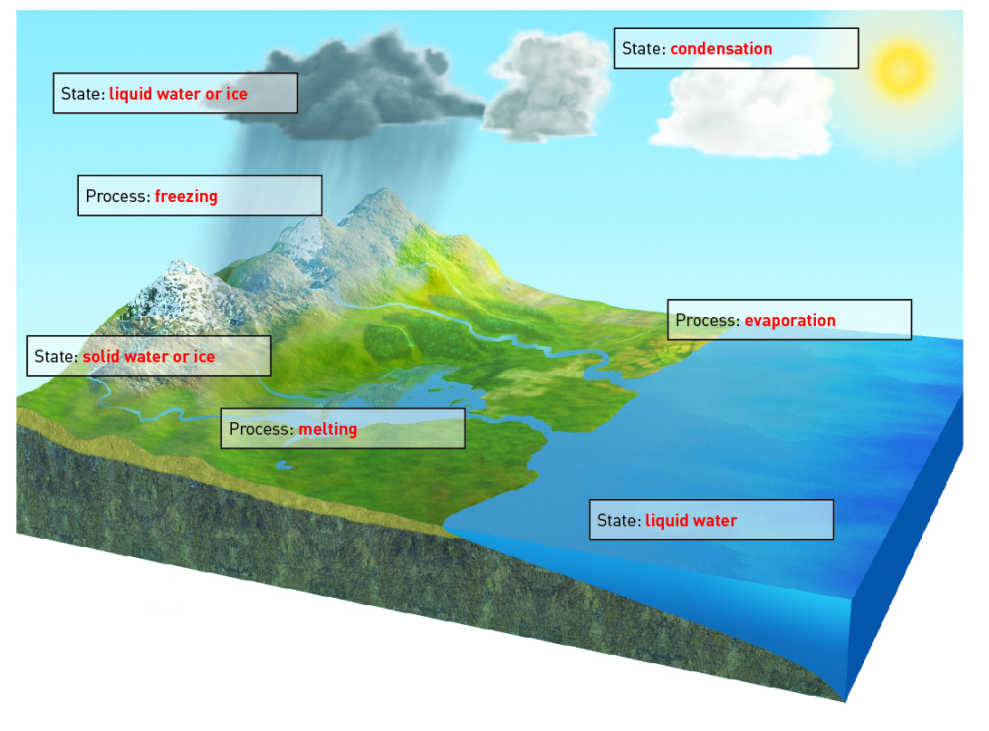

EXTEND YOUR UNDERSTANDING

4 Humans take in and excrete water in their contribution to the water cycle. Research the movement of water into and out of the human body through these three systems:

• Respiratory (breathing)

When we inhale, air moving through our airways becomes humidified (adding moisture to it). When we exhale, the humidified air is lost to the outside environment.

• Urinary (urinating)

Kidneys process blood, including plasma, which is mostly water. Approximately 1–2 litres of water is lost daily from our bodies as urine.

• Integumentary (sweating)

We sweat throughout the day to help remove extra body heat, but in the process lose up to approximately half a litre of water through the pores in our skin.

3.3 Factors in nature affect the water cycle

Student worksheet answers (pages 52–53)

Land of droughts and flooding rains

1 The diagram below shows the processes of El Niño. Fill in the correct boxes with the following information: the process during El Niño or the water cycle or the state of matter.

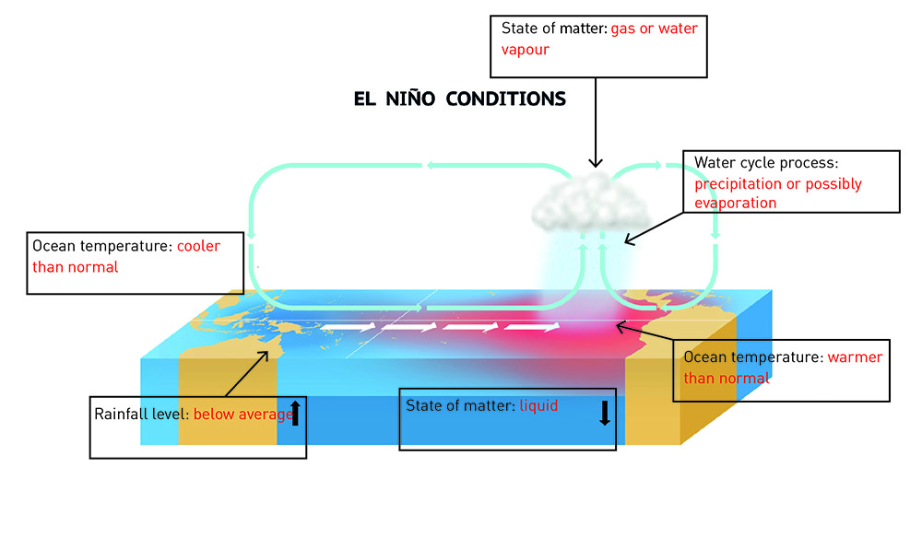

2 Describe how El Niño affects Peru.

El Niño causes higher than average rainfall in Peru because of the warmer than normal ocean temperatures.

3 Describe how La Niña affects Peru.

La Niña causes lower than average rainfall in Peru because of the lower than average ocean temperatures.

4 The diagram below shows the processes of La Niña. Fill in the correct boxes with the following information: the process during La Niña or the water cycle or the state of matter.

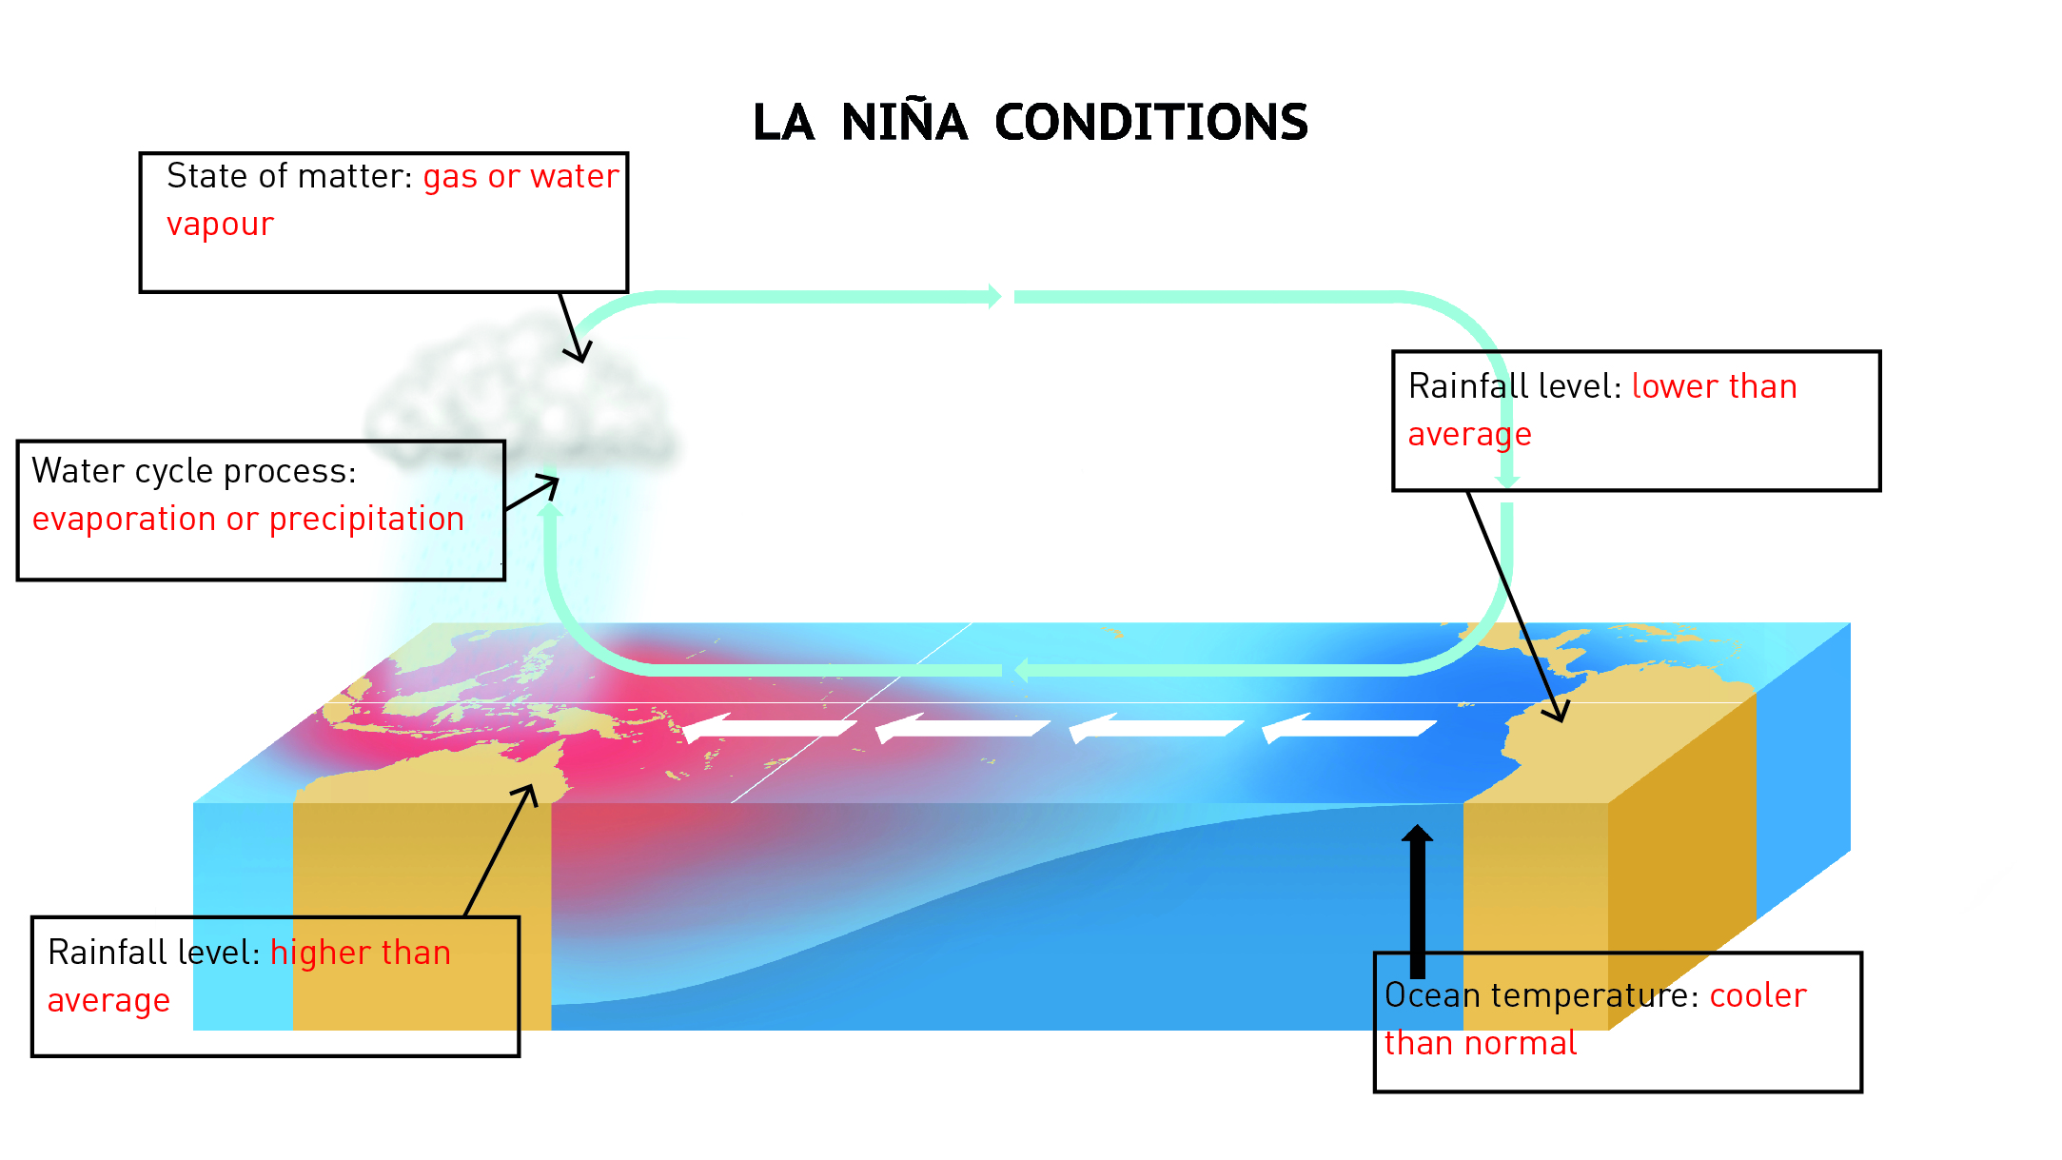

EXTEND YOUR UNDERSTADNING

5 The Australian government’s Bureau of Meteorology can predict El Niño and La Niña events by using the ENSO tracker. Using the Bureau of Meteorology’s website (<http://www.bom.gov.au/climate/enso/tracker/#tabs=Summary>), research the following questions:

a What is the ENSO tracker?

The ENSO tracker is the El Niño–Southern Oscillation (ENSO) tracker. It tracks changes in the likelihood of an El Niño or La Niña event occurring.

b What are the criteria used to determine whether an El Niño event is occurring?

The criteria are sea surface temperature, trade wind strength, SOI and climate models.

c What are the criteria used to determine whether a La Niña event is occurring?

The criteria are sea surface temperature, trade wind strength, SOI and climate models.

d Observe the ‘recent ENSO values’ graph for the years from 1980 to the present year.

i How many El Niño events occurred?

Student responses will vary, but prior to 2015 there were nine El Niño events.

ii How many La Niña events occurred?

Student responses will vary, but prior to 2015 there were 11 La Niña events.

e Is Australia likely to encounter El Niño or La Niña over the next 12 months?

Student responses will vary, but from 2015 Australia will likely encounter an El Niño event.

3.4 Human management affects the water cycle

Student worksheet answers (pages 54–55)

What’s the use of water?

1 Approximately 65% of the water we use in Australia is used for agricultural purposes.

a What part of the water cycle provides water for agriculture without the use of irrigation?

Precipitation provides water for agriculture.

b What are three sources of water for irrigation?

Water for irrigation comes from ground water, rivers and lakes.

c In the table below, write three pros and three cons of using water for agriculture.

|  |  |
| --- | --- |
| **Pros of using water for agriculture** | **Cons of using water for agriculture** |
| Increases food production | Less water available for the environment |
| Crops grow more quickly and are better quality | Pollution from farms can flow into rivers |
| Provides employment for people involved in the production, distribution and sale of crops | Natural waterways are changed for dams, irrigation etc. |

2 Industry has a major effect on the water cycle through the emission of pollution due to the burning of fossil fuels. If pollution from burning fossil fuels mixes with water vapour in the clouds, how could this affect humans?

Pollution mixing with the water vapour in the clouds could contaminate the precipitation (some students may refer to acid rain). This could affect the quality of the water for human uses.

3 The Thomson Dam and the Warragamba Dam are marked on map below.

a Which city would use the Thomson Dam for part of its domestic water supply?

Melbourne would use the Thomson Dam for its water supply.

b Which city would use the Warragamba Dam for part of its domestic water supply?

Sydney would use the Warragamba Dam for its water supply.

c How might agriculture use the water from the two dams?

Agriculture may use the water from the dams for irrigation.

EXTEND YOUR UNDERSTANDING

4 Research the Wonthaggi Desalination plant in Victoria. Discover why it was built and explain how this is linked to human impact on the water cycle.

Student responses will vary. Population growth placed more demand on water supplies, and the State's water storage dams decreased between 1998 and 2007 because of a prolonged drought.

3.5 Science as a human endeavour: Water is a precious resource

Student worksheet answers (pages 56–57)

There’s precious little water

1 If the world’s water was represented by a 1 litre (1000 millilitre) container, try to calculate the number of millilitres for the following categories:

a Salt water

975 mL (1000 x 97.5%)

b Fresh water

25 mL (1000 x 2.5%)

c

i Fresh water in ice caps and glaciers

17.5 mL (25 x 70%)

ii Fresh water in ground water and soil

7.25 mL (25 x 29%)

iii Fresh water in lakes and rivers

2.5 mL (25 x 1%)

2 The amount of water available per person on Earth is estimated to be 222 billion litres. Using Figure 3.19 in the textbook as a guide, complete the table below.

|  |  |  |
| --- | --- | --- |
| Location of water | Amount of water available per person (litres) | % Total water |
| Total water on Earth | 222 billion | 100 |
| Fresh water on Earth | 5.5 billion | 2.5 |
| Liquid (not frozen) fresh water on Earth | 1.6 billion | 0.75 |
| Fresh water in lakes and rivers | 5.5 million | 0.025 |

3 The amount of water available per person is an enormous amount, but not when you consider the chart below (keeping in mind this shows water use in Australia only). Does this figure tell the true story of the water available per person for their own use?

This figure does not tell the true story because the majority of water use is not for domestic use, and not all the water in lakes and rivers is used by humans (most of it remains in the environment).

EXTEND YOUR UNDERSTANDING

4 How many litres of water do you think you personally use (drink, flush, wash) each day? Compare your response with that of a classmate or family member.

Student responses will vary.